

Semester One

Examination 2023

Question/Answer booklet

HUMAN BIOLOGY
UNIT 1

Name: _______________________________________________________

Teacher: ___________________________________________________

Time allowed for this paper

Reading time before commencing work: ten minutes
Working time for the paper: two and a half hours

Materials required/recommended for this paper
To be provided by the supervisor
This Question/Answer booklet
Multiple-choice answer sheet

To be provided by the candidate
Standard items: pens (blue/black preferred), pencils (including coloured), sharpener, correction fluid/tape, eraser, ruler, highlighters

Special items: up to three calculators, which do not have the capacity to create or store programmes or text, are permitted in this ATAR course examination

Important notice to candidates
No other items may be taken into the examination room. It is your responsibility to ensure that you do not have any unauthorised material. If you have any unauthorised material with you, hand it to the supervisor before reading any further.
Structure of this paper

Section | Number of questions available | Number of questions to be answered | Suggested working time  (minutes) | Marks available | Percentage of examination
Section One  Multiple-choice | 25 | 25 | 30 | 25 | 30
Section Two  Short answer | 7 | 7 | 80 | 90 | 50
Section Three  Extended Answer  Part 1  Part 2 | 2 | 1 | 40 | 20 | 20
 | 2 | 1 |  | 15
 |  |  | Total | 150 | 100

Instructions to candidates

- The rules for the conduct of Western Australian examinations are detailed in the Year 12 Information Handbook 2023: Part II Examinations. Sitting this examination implies that you agree to abide by these rules.

- Answer the questions according to the following instructions.

Section One: Answer all questions on the separate Multiple-choice answer sheet provided. For each question, shade the box to indicate your answer. Use only a blue or black pen to shade the boxes. Do not use erasable or gel pens. If you make a mistake, place a cross through that square, then shade your new answer. Do not erase or use correction fluid/tape. Marks will not be deducted for incorrect answers. No marks will be given if more than one answer is completed for any question.

Section Two: Write your answers in this Question/Answer booklet preferably using a blue/black pen. Do not use erasable or gel pens. Wherever possible, confine your answers to the line spaces provided.

Section Three: Consists of two parts each with two questions. You must answer one question from each part. Tick the box next to the question you are answering. Write your answers in this Question/Answer booklet preferably using a blue/black pen. Do not use erasable or gel pens.

- You must be careful to confine your responses to the specific questions asked and follow any instructions that are specific to a particular question.

- Supplementary pages for planning/continuing your answers to questions are provided at the end of this Question/Answer booklet. If you use these pages to continue an answer, indicate at the original answer where the answer is continued, i.e. give the page number.

This section has 25 questions. Answer all questions on the separate Multiple-choice answer sheet provided. For each question, shade the box to indicate your answer. Use only a blue or black pen to shade the boxes. Do not use erasable or gel pens. If you make a mistake, place a cross through that square, then shade your new answer. Do not erase or use correction fluid/tape. Marks will not be deducted for incorrect answers. No marks will be given if more than one answer is completed for any question.

Suggested working time: 30 minutes.
_________________________________________________________________________________

1. Where is the energy from cellular respiration stored within the adenosine triphosphate (ATP) molecule?

- within the high energy electrons surrounding the atoms of the molecule
- in the phosphate bond between ADP and the third phosphate group
- in the cytoplasm of cells within the liver and muscle
- within the covalent bonds holding the atoms together within the molecule

2. A Year 11 Human Biology student is wanting to speed up the reaction rate of pepsin - a gastric enzyme in the human body. Which of the following should she do?

- raise the temperature of the solution to 50°C
- ensure the pH of the solution is 7.0
- add more substrate to the mixture
- increase the enzyme concentration

3. The London Marathon sees over 42 000 people run 42.2 km. Which of the following would most likely be occurring in the muscles of the runners as they finish the race?

- anaerobic respiration
- reduction in oxygen debt
- aerobic respiration
- decrease in lactic acid

4. Inorganic catalysts, such as titanium chloride, are used by chemists, whereas cells use organic catalysts called enzymes. Which of the following correctly identifies an advantage and a disadvantage of using enzymes as catalysts?

 | Advantage | Disadvantage
(a) | can be used for a range of reactions | require constant removal of product
(b) | create high yields of product | can become denatured by temperature
(c) | can be reused | sensitive to changes in pH
(d) | are specific for a particular substrate | require a lot of energy
5. Bowel cancer is an uncontrolled growth of cells in the wall of the large intestine. Which of the following is not considered to be a risk factor for bowel cancer?

- high fibre diet
- diet high in red meat
- obesity
- physical inactivity

6. Which of the following statements best explains why salivary amylase would not be responsible for starch digestion in the small intestine?

- the stomach has a low pH and would denature the amylase
- salivary amylase works best at a pH of 6-7
- it takes less time for starch to digest at pH 3
- all the starch has been digested in the mouth

7. A blood sample is drawn from a patient experiencing a sore throat and runny nose. Which of the following blood cells would you expect to be elevated in number?

- erythrocytes
- platelets
- thrombocytes
- leucocytes

8. Which of the following sets of joints allows both abduction and adduction movement?

- vertebrae and knuckle
- hip and shoulder
- knee and elbow
- ankle and wrist

9. The heart is associated with the major blood vessels listed below:

- pulmonary artery
- superior vena cava
- pulmonary vein
- inferior vena cava
- aorta

Which of the following best identify the vessels associated with the heart that transport oxygenated blood?

- V only
- I and V
- III and V
- II, III and IV

Question 10 refers to the diagram of a cell type found in a particular tissue as shown below.

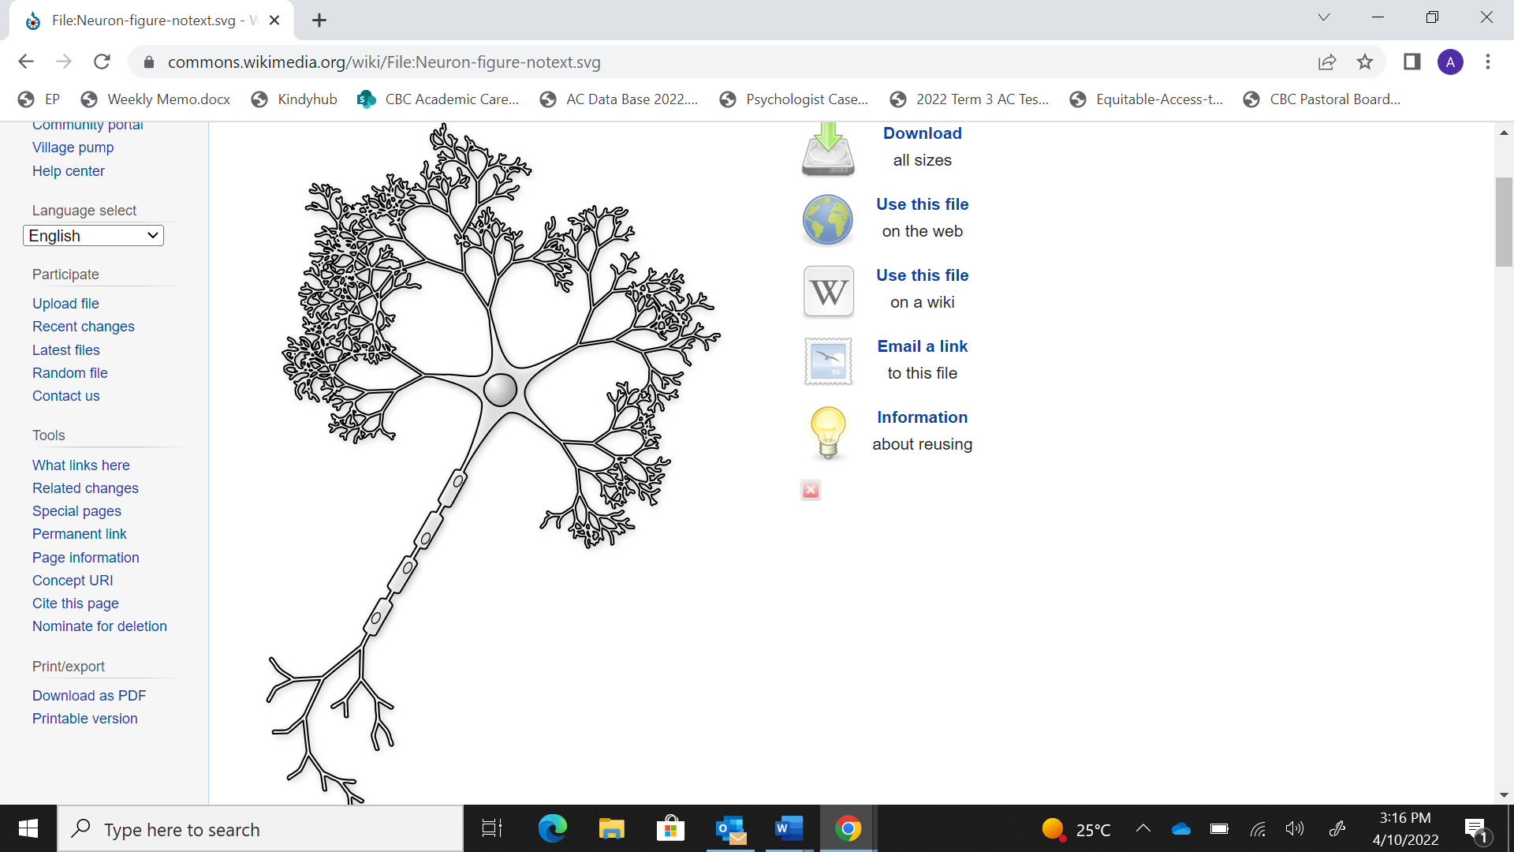

10. The function of the tissue this cell shown above is associated with is to

- carry messages between different parts of the body.
- line the internal cavities of organs, such as the stomach.
- voluntarily allow movement of muscles and bones.
- provide support for the body.

11. Which of the following options correctly identify the variables in a scientific experiment?

 |  | Controlled | Independent | Dependent
 |  | measured | changed | constant
 |  | changed | constant | measured
 |  | constant | measured | changed
 |  | constant | changed | measured

Question 12 refers to the Department of Health WA data table below that shows the weekly admission and vaccination data for COVID-19 in August 2022.

Date range | Cases | Hospitalisations | ICU | Deaths
Week 1 | 16 079 | 117 | 5 | 14
Week 2 | 12 313 | 81 | 1 | 23
Week 3 | 9 381 | 63 | 5 | 17
Week 4 | 7 660 | 48 | 0 | 22

12. It can be concluded from the data that

- the number of infections increased over the month.
- in Week 2, 0.19% of cases resulted in death.
- the average ICU rate over the month was 2 admissions.
- the greatest rate of hospitalisations was in Week 3.

13. A doctor collected the total amount of urine produced by a patient in 24hrs. The first collection measured 1800 mL of urine, whilst the second collection was 1600 mL. Which of the following correctly states the percentage change in volume?

- 11% decrease
- 8% increase
- 11% increase
- 8% decrease

Question 14 refers to the diagram below of a human body.

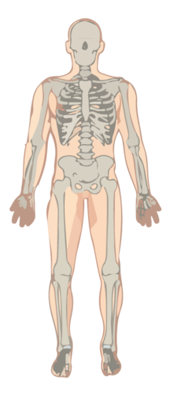

14. What term best describes the level of organisation depicted in the diagram above?

- cell
- tissue
- organ
- system

Question 15 refers to the diagram below showing the response of erythrocytes in three separate solutions.
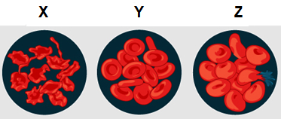

15. Which of the following identifies the type of solution that the erythrocytes have been exposed to in solution X, Y, and Z?

 |  | X | Y | Z
 |  | isotonic | hypertonic | hypotonic
 |  | hypotonic | isotonic | hypertonic
 |  | hypertonic | isotonic | hypotonic
 |  | hypertonic | hypotonic | isotonic

16. Diffusion can be distinguished as either simple or facilitated. The difference between these types of diffusion is

- simple occurs at any location on the membrane, whilst facilitated occurs via channels.
- facilitated is an active process, whilst simple is passive.
- simple works down the concentration gradient, whilst facilitated works up the gradient.
- facilitated always involves the cell membrane, whilst simple does not.

17. Which of the following correctly identifies the main process and location by which simple sugars, such as glucose, are absorbed into the body?

- facilitated diffusion; lacteals in the large intestine
- active transport; lacteals in the small intestine
- simple diffusion; blood capillaries in the small intestine
- active transport; blood capillaries in the small intestine

18. Whilst playing basketball, an athlete jumped up for a rebound. Upon landing, she heard a loud pop, experienced instant bruising and was unable to straighten her knee. What tissue did she most likely injure?

- muscle
- cartilage
- ligament
- Bone
Question 19 refers to the diagram of the digestive system below.

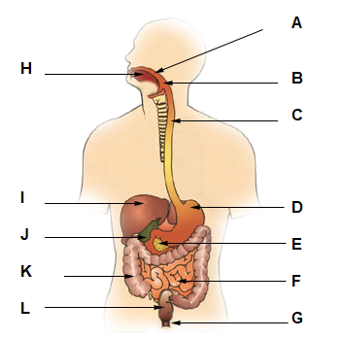

19. Which of the following are accessory organs of the digestive system?

- A, L, and J
- B, E and G
- E, I, and J
- I, J and G

20. Strength training of the arm muscles often includes bicep curls, which involves repeated flexion and extension at the elbow joint. During the process of extension, the biceps relax whilst the triceps contracts. Which of the following identifies the role of the muscles in this movement?

- the tricep is the antagonist and the bicep is the agonist
- the bicep is the synergist and the tricep is the antagonist
- the bicep is the antagonist and the tricep is the agonist
- the tricep is the stabiliser and the bicep is the synergist

21. Injury to the skull often results in the fracture of the bone well before any damage to the joints found there. The best reason for this is that skull joints are

- slightly moveable, allowing the plates of the skull to slide past each other.
- fibrous, which are very difficult to damage.
- cartilaginous, that cushions the bones during impact.
- synovial joints, limited in movement by the ligaments in the skull.

Question 22 and 23 refer to the microscopic structure of compact bone shown below.

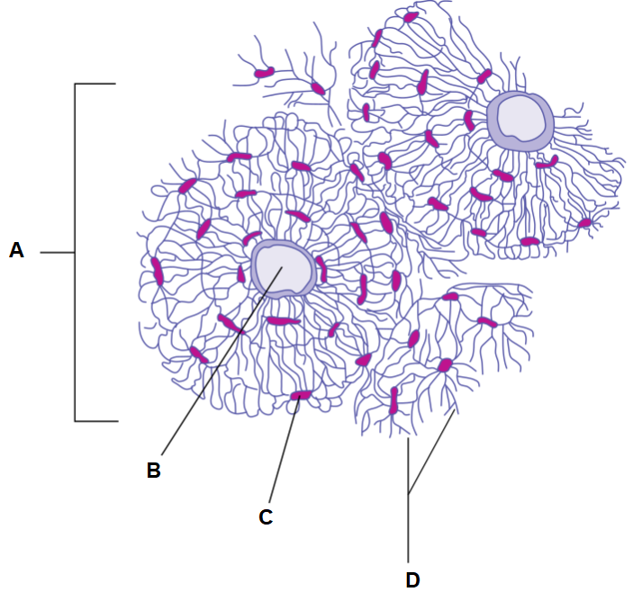

22. The Haversian canal, identified by the letter B, contains

- capillaries and nerve fibres.
- osteocytes embedded with a collagen matrix.
- yellow bone marrow and stored fat.
- stores of calcium and phosphorous.

23. What is the function of the components labelled D?

(a) increase the strength of the bone by connecting the cells
(b) allow transport of materials between cells
(c) house the osteocytes allowing bone integrity to be maintained
(d) allow blood vessels and nerves to pass through the bone

24. Leukaemia is a cancer of the tissue that forms blood, with patients often receiving platelet transfusions as part of their care. Which of the following symptoms would be associated with a low platelet count?

- recurrent nosebleeds
- swollen lymph nodes and an enlarged liver
- high body temperatures and chills
- loss of weight without trying

25. Elimination and excretion are often used interchangeably; however, biologically, they are quite different. All the following are excreted from the body except for

- carbon dioxide.
- urea.
- bile.
- undigested food.

END OF SECTION ONE

Section Two: Short answer 50% (90 Marks)

This section has seven questions. Answer all questions. Write your answers in the spaces provided.

Supplementary pages for planning/continuing your answers to questions are provided at the end of this Question/Answer booklet. If you use these pages to continue an answer, indicate at the original answer where the answer is continued, i.e. give the page number.

Suggested working time: 80 minutes.
_________________________________________________________________________________

Question 26 (10 marks)

In 2002, a controlled trial was performed to determine if two procedures performed during arthroscopic surgery for osteoarthritis were effective in relieving knee pain. Participants were aged 75 or less, with 93% male and 60% Caucasian. 60 participants were given a placebo operation, whilst the other two-thirds had either one of the two procedures: a lavage or debridement. The trial ran for 2 years, with knee pain scores recorded. The results are shown below.

 | Procedure (Average Scores on Knee Pain Scale)
Time (Weeks) | Placebo | Lavage | Debridement
0 | 60 | 61 | 58
26 | 57 | 59 | 56
78 | 52 | 56 | 51
104 | 55 | 55 | 53

- Explain why the researchers included a placebo operation in this study. (2 marks)

___________________________________________________________________________
___________________________________________________________________________
___________________________________________________________________________

- Graph the results from the 2002 trial on the grid provided below. (5 marks)

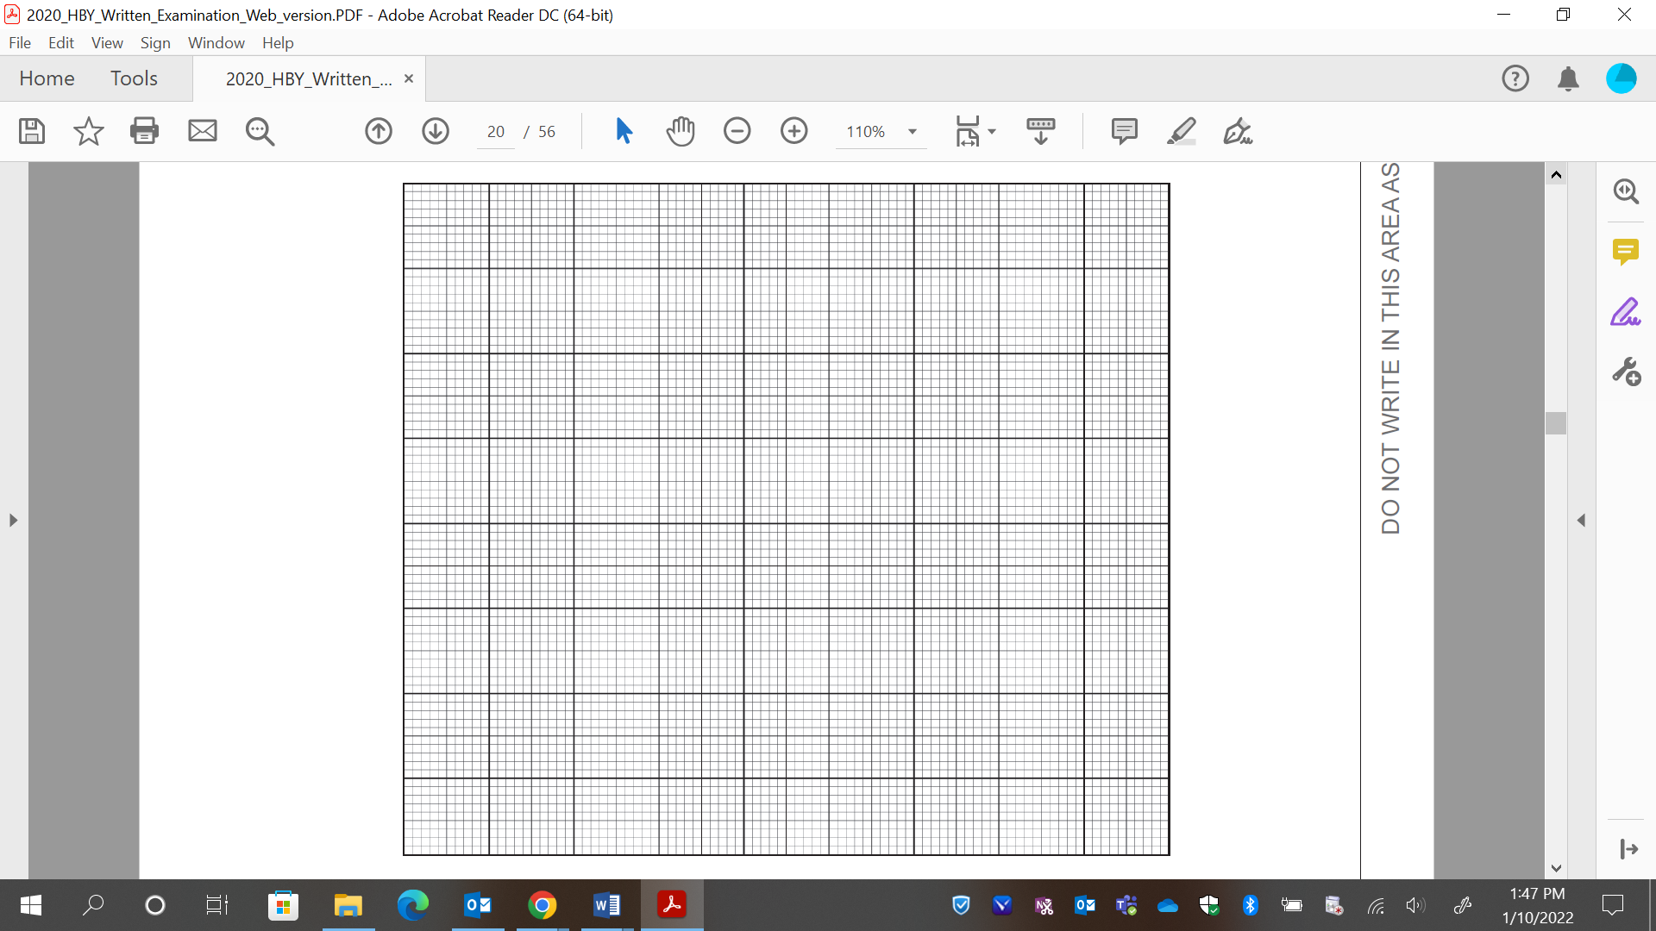

A spare grid is provided at the end of this Question/Answer Booklet. If you need to use it, cross out this attempt and indicate that you have redrawn it on the spare grid

Question 26 (continued)

- By the age of 70, everyone will have some symptoms of osteoarthritis. Outline the cause of the joint pain that osteoarthritis sufferers experience.
(3 marks)

___________________________________________________________________________
___________________________________________________________________________
___________________________________________________________________________
___________________________________________________________________________

Question 27 (12 marks)

The human body is made up of approximately 37.2 trillion cells, each of these with a set of specific cell organelles that maintain life processes. The production of proteins is one such important process occurring within a cell.

(a) Briefly outline the function of the following organelles regarding protein production.
(3 marks)

Organelle | Function
Nucleus
Ribosomes
Golgi body

(b) Proteins can become integrated within the cell membrane. In the space below, draw a fully labelled diagram of the fluid mosaic model to represent the structure of a cell membrane.
(5 marks)

Question 27 (continued)

(c) Describe how ineffective mitochondria would affect a cell’s general function within the body.
(4 marks)

___________________________________________________________________________
___________________________________________________________________________
___________________________________________________________________________
___________________________________________________________________________
___________________________________________________________________________
___________________________________________________________________________

Question 28 (12 marks)

Penicillin was discovered in 1928, with the first patient treated with the antibiotic 20 years later. It works through the process of enzyme inhibition, stopping bacteria from synthesising a cell wall and therefore causing it to die.

(a) Explain how an enzyme reaction would differ in the presence of an enzyme inhibitor.
(6 marks)

___________________________________________________________________________
___________________________________________________________________________
___________________________________________________________________________
___________________________________________________________________________
___________________________________________________________________________
___________________________________________________________________________
___________________________________________________________________________
___________________________________________________________________________
___________________________________________________________________________

(b) Several other factors can also affect the function of enzymes. Match the appropriate reactivity graphs to the factors identified below.
(4 marks)

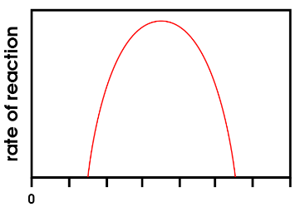 | 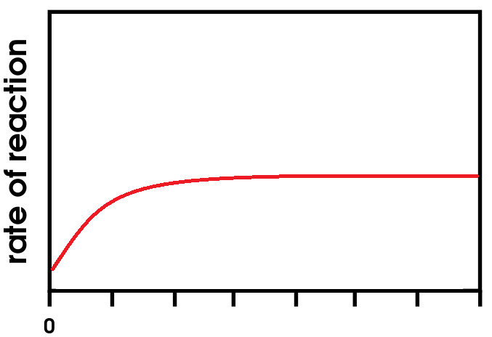 | 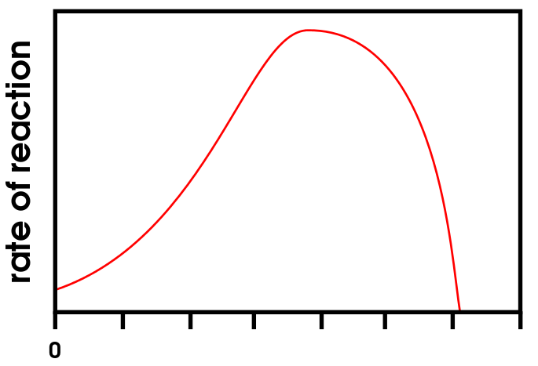 | 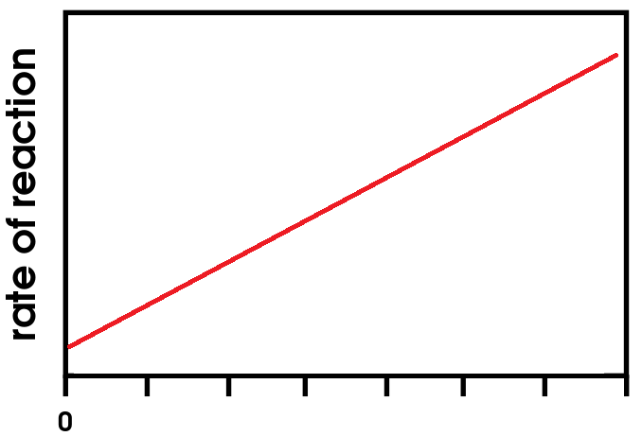
Graph A | Graph B | Graph C | Graph D

- Substrate concentration: ___________________

- Temperature: ___________________

- pH: ___________________

- Enzyme concentration: ___________________

A diagram of the parts of the stomach is shown below.

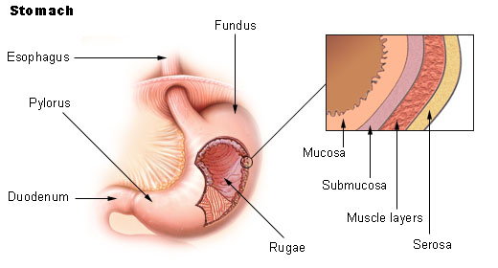

(c) Unlike the rest of the alimentary canal, the stomach has a third muscle layer. State the name of this muscle layer and outline why it is found in the stomach.
(2 marks)

___________________________________________________________________________
___________________________________________________________________________
___________________________________________________________________________

Question 29 (12 marks)

Helicobacter pylori is a bacterium that damages the protective mucous coating of the digestive system. This damage can lead to the formation of peptic ulcers in the duodenum.

(a) Why are peptic ulcers more likely to be found in the duodenum? (2 marks)

___________________________________________________________________________
___________________________________________________________________________

(b) H. pylori infections can also cause chronic diarrhoea in early infancy. Define diarrhoea and explain its cause.
(5 marks)

___________________________________________________________________________
___________________________________________________________________________
___________________________________________________________________________
___________________________________________________________________________
___________________________________________________________________________
___________________________________________________________________________
___________________________________________________________________________

LDL cholesterol, often referred to as “bad” cholesterol, is transported into cells of the body through vesicular transport.

(c) Outline the steps involved in taking up cholesterol into a cell.
(3 marks)

___________________________________________________________________________
___________________________________________________________________________
___________________________________________________________________________
___________________________________________________________________________

(d) Most cholesterol is produced in the liver.
What digestive substance is produced using cholesterol from the liver and where is it stored?
(2 marks)

___________________________________________________________________________
___________________________________________________________________________

Question 30 (10 marks)

The diagram below illustrates the respiratory system.

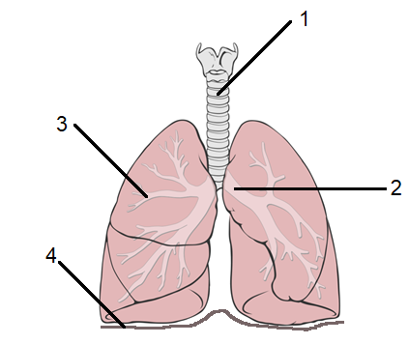

(a) Identify the organs labelled by the following numbers: (2 marks)

1: ______________________________

3: ______________________________

(b) Describe how the muscle identified at label 4 in the image above is involved in inspiration.
(3 marks)

___________________________________________________________________________
___________________________________________________________________________
___________________________________________________________________________
___________________________________________________________________________

(c) Outline how oxygen and carbon dioxide are exchanged between alveoli and blood capillaries. (5 marks)

___________________________________________________________________________
___________________________________________________________________________
___________________________________________________________________________
___________________________________________________________________________
___________________________________________________________________________
___________________________________________________________________________
___________________________________________________________________________

Question 31 (13 marks)

Approximately 10% of a person’s body weight is made up of blood, equating to about 5L. A loss of 40% or more of your blood volume will result in death, with blood transfusions required to stop this from occurring.

(a) Outline how molecules found on the surface of red blood cells and in the plasma are important in blood transfusions.
(5 marks)

___________________________________________________________________________
___________________________________________________________________________
___________________________________________________________________________
___________________________________________________________________________
___________________________________________________________________________
___________________________________________________________________________
___________________________________________________________________________
___________________________________________________________________________
___________________________________________________________________________

One of the functions of blood is to transport oxygen to cells and carbon dioxide away from cells.

(b) Explain how carbon dioxide is transported in the blood. (3 marks)

___________________________________________________________________________
___________________________________________________________________________
___________________________________________________________________________
___________________________________________________________________________

Carbon dioxide is a cellular waste removed from the body via the lungs. Other wastes created in the body are removed via urine. Normal urine is composed of water, solutes and wastes, with approximately 2% being urea.

(c) What would you expect to happen to the percentage of urea in a person’s urine if they ate a high-protein diet? Justify your answer.
(2 marks)

___________________________________________________________________________
___________________________________________________________________________
___________________________________________________________________________

Nutrients and wastes are transferred between cells and extracellular space via transport mechanisms.

(d) Complete the table below identifying the transport mechanism associated with each of the stated processes.
(3 marks)

Process | Transport Mechanism
Water-soluble vitamins being absorbed into the blood capillaries of the villi
Uptake of amino acids into the villi of the small intestine after a meal
Water movement from the kidney tubules into the blood

Question 32 (11 marks)

The diagram below is an illustration of a relaxed muscle fibre.

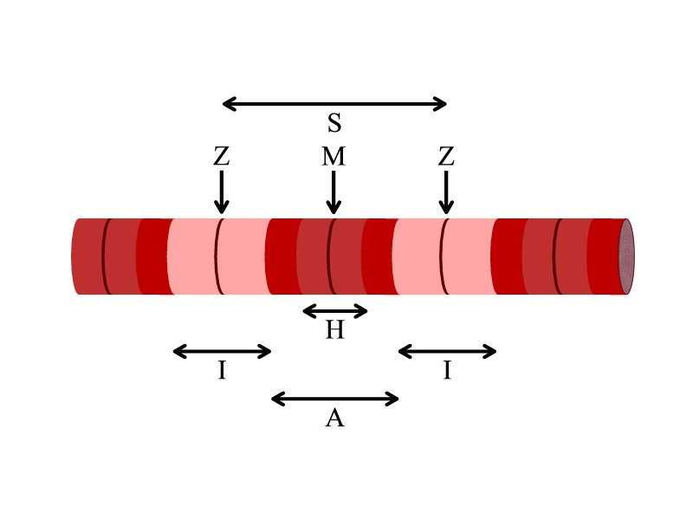

(a) When a muscle fibre contracts, the sarcomere will shorten though the A-band will remain the same length. Explain why this occurs.
(3 marks)

___________________________________________________________________________
___________________________________________________________________________
___________________________________________________________________________
___________________________________________________________________________

Cardiac muscle tissue is involuntary, ensuring that the muscle rhythmically contracts to pump blood around the body.

(b) Briefly describe the structure of cardiac muscle tissue. (2 marks)

___________________________________________________________________________
___________________________________________________________________________

A microscopic image depicting two types of blood vessels is shown below.

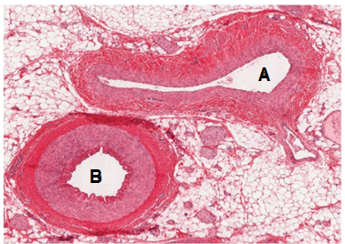

(c) Identify the type of vessels labelled A and B. Justify your answers. (2 marks)

___________________________________________________________________________
___________________________________________________________________________
___________________________________________________________________________

(d) Erythrocytes have a very particular structure. How does the structure suit the function of the cells?
(4 marks)

___________________________________________________________________________
___________________________________________________________________________
___________________________________________________________________________
___________________________________________________________________________
___________________________________________________________________________

END OF SECTION TWO

Section Three: Extended answer 20% (35 marks)
This section contains four questions. You must answer two questions.
Questions 33 and 34 are from Part 1. Question 35 and 36 are from Part 2. Answer one question from Part 1 and one question from Part 2.

Responses could include clearly labelled diagrams with explanatory notes; lists of points with linking sentences; clearly labelled tables and graphs; and annotated flow diagrams with introductory notes.

Supplementary pages for planning/continuing your answers to questions are provided at the end of this Question/Answer booklet. If you use these pages to continue an answer, indicate at the original answer where the answer is continued, i.e. give the page number.

Suggested working time: 40 minutes
_________________________________________________________________________________

Part 1

Choose either Question 33 or Question 34.

Indicate the question you will answer by ticking the box next to the question. Write your answer on pages 28–32. When you have answered your first question, turn to page 34 and indicate on that page the second question you will answer.

Question 33 (20 marks)

In every living cell, enzyme controlled chemical reactions take place continuously and are often linked together.

- State the name given to this set of reactions and describe the two types that occur in the body. Give an example of each type.
(7 marks)

Cells require nutrients in order to undertake life processes, such as growth and repair. The digestive system extracts these nutrients from the food we eat through chemical and mechanical digestion.

- The mouth, stomach and small intestine utilise chemical and mechanical digestion. Differentiate between the two types of digestion and list the functions associated with the three named parts of the digestive system.
(13 marks)

Question 34 (20 marks)

Crohn’s disease is an autoimmune condition which damages the lining of the small intestine, leading to inflammation.

- Describe the lining of a healthy small intestine and outline why an individual with
unmanaged Crohn’s tend to lose weight.
(8 marks)

Emphysema is a lung disease most often attributed to smoking. People with emphysema have damaged alveoli and decreased blood flow.

- Explain how the structure of the lungs allow for efficient gas exchange. Predict some of the symptoms that emphysema patients would exhibit.
(12 marks)

Question number: _______________
___________________________________________________________________________________________________________________________________________________________________________________________________________________________________________________________________________________________________________________________________________________________________________________________________________________________________________________________________________________________________________________________________________________________________________________________________________________________________________________________________________________________________________________________________________________________________________________________________________________________________________________________________________________________________________________________________________________________________________________________________________________________________________________________________________________________________________________________________________________________________________________________________________________________________________________________________________________________________________________________________________________________________________________________________________________________________________________________________________________________________________________________________________________________________________________________________________________________________________________________________________________________________________________________________________________________________________________________________________________________________________________________________________________________________________________________________________________________________________________________________________________________________________________________________________________________________________________________________________________________________________________________________________________________________________________________________________
Question number: _______________
__________________________________________________________________________________________________________________________________________________________________________________________________________________________________________________________________________________________________________________________________________________________________________________________________________________________________________________________________________________________________________________________________________________________________________________________________________________________________________________________________________________________________________________________________________________________________________________________________________________________________________________________________________________________________________________________________________________________________________________________________________________________________________________________________________________________________________________________________________________________________________________________________________________________________________________________________________________________________________________________________________________________________________________________________________________________________________________________________________________________________________________________________________________________________________________________________________________________________________________________________________________________________________________________________________________________________________________________________________________________________________________________________________________________________________________________________________________________________________________________________________________________________________________________________________________________________________________________________________________________________________________________

Question number: _______________
_____________________________________________________________________________________________________________________________________________________________________________________________________________________________________________________________________________________________________________________________________________________________________________________________________________________________________________________________________________________________________________________________________________________________________________________________________________________________________________________________________________________________________________________________________________________________________________________________________________________________________________________________________________________________________________________________________________________________________________________________________________________________________________________________________________________________
______________________________________________________________________________________________________________________________________________________________________________________________________________________________________________________________________________________________________________________________________________________________________________________________________________________________________________________________________________________________________________________________________________________________________________________________________________________________________________________________________________________________________________________________________________________________________________________________________________________________________________________________________________________________________________________________________________________________________________________________________________________________________________________________________________________________________________________________________________________________________________
Question number: _______________
__________________________________________________________________________________________________________________________________________________________________________________________________________________________________________________________________________________________________________________________________________________________________________________________________________________________________________________________________________________________________________________________________________________________________________________________________________________________________________________________________________________________________________________________________________________________________________________________________________________________________________________________________________________________________________________________________________________________________________________________________________________________________________________________________________________________________________________________________________________________________________________________________________________________________________________________________________________________________________________________________________________________________________________________________________________________________________________________________________________________________________________________________________________________________________________________________________________________________________________________________________________________________________________________________________________________________________________________________________________________________________________________________________________________________________________________________________________________________________________________________________________________________________________________________________________________________________________________________________________________________________________________

Question number: _______________
___________________________________________________________________________________________________________________________________________________________________________________________________________________________________________________________________________________________________________________________________________________________________________________________________________________________________________________________________________________________________________________________________________________________________________________________________________________________________________________________________________________________________________________________________________________________________________________________________________________________________________________________________________________________________________________________________________________________________________________________________________________________________________________________________________________________________________________________________________________________________________________________________________________________________________________________________________________________________________________________________________________________________________________________________________________________________________________________________________________________________________________________________________________________________________________________________________________________________________________________________________________________________________________________________________________________________________________________________________________________________________________________________________________________________________________________________________________________________________________________________________________________________________________________________________________________________________________________________________________________________________________________________________________________________________________________________________
Part 2

Choose either Question 35 or Question 36.

Indicate the question you will answer by ticking the box next to the question. Write your answer on the pages provided.

_________________________________________________________________________________

Question 35 (15 marks)

- Outline the structure of a nephron beginning at the renal corpuscle. State the activities which occur at each region.
(15 marks)

Question 36 (15 marks)

- The skeletal system is made up of bone that is far more than just a framework giving shape to the body. Outline the macroscopic structure of a long bone and describe how the features contribute to the functions of the human skeleton.
(15 marks)

END OF QUESTIONS

Question number: _______________
___________________________________________________________________________________________________________________________________________________________________________________________________________________________________________________________________________________________________________________________________________________________________________________________________________________________________________________________________________________________________________________________________________________________________________________________________________________________________________________________________________________________________________________________________________________________________________________________________________________________________________________________________________________________________________________________________________________________________________________________________________________________________________________________________________________________________________________________________________________________________________________________________________________________________________________________________________________________________________________________________________________________________________________________________________________________________________________________________________________________________________________________________________________________________________________________________________________________________________________________________________________________________________________________________________________________________________________________________________________________________________________________________________________________________________________________________________________________________________________________________________________________________________________________________________________________________________________________________________________________________________________________________________________________________________________________________________
Question number: _______________
__________________________________________________________________________________________________________________________________________________________________________________________________________________________________________________________________________________________________________________________________________________________________________________________________________________________________________________________________________________________________________________________________________________________________________________________________________________________________________________________________________________________________________________________________________________________________________________________________________________________________________________________________________________________________________________________________________________________________________________________________________________________________________________________________________________________________________________________________________________________________________________________________________________________________________________________________________________________________________________________________________________________________________________________________________________________________________________________________________________________________________________________________________________________________________________________________________________________________________________________________________________________________________________________________________________________________________________________________________________________________________________________________________________________________________________________________________________________________________________________________________________________________________________________________________________________________________________________________________________________________________________________

Question number: _______________
_____________________________________________________________________________________________________________________________________________________________________________________________________________________________________________________________________________________________________________________________________________________________________________________________________________________________________________________________________________________________________________________________________________________________________________________________________________________________________________________________________________________________________________________________________________________________________________________________________________________________________________________________________________________________________________________________________________________________________________________________________________________________________________________________________________________________
______________________________________________________________________________________________________________________________________________________________________________________________________________________________________________________________________________________________________________________________________________________________________________________________________________________________________________________________________________________________________________________________________________________________________________________________________________________________________________________________________________________________________________________________________________________________________________________________________________________________________________________________________________________________________________________________________________________________________________________________________________________________________________________________________________________________________________________________________________________________________________
Question number: _______________
__________________________________________________________________________________________________________________________________________________________________________________________________________________________________________________________________________________________________________________________________________________________________________________________________________________________________________________________________________________________________________________________________________________________________________________________________________________________________________________________________________________________________________________________________________________________________________________________________________________________________________________________________________________________________________________________________________________________________________________________________________________________________________________________________________________________________________________________________________________________________________________________________________________________________________________________________________________________________________________________________________________________________________________________________________________________________________________________________________________________________________________________________________________________________________________________________________________________________________________________________________________________________________________________________________________________________________________________________________________________________________________________________________________________________________________________________________________________________________________________________________________________________________________________________________________________________________________________________________________________________________________________

Question number: _______________
__________________________________________________________________________________________________________________________________________________________________________________________________________________________________________________________________________________________________________________________________________________________________________________________________________________________________________________________________________________________________________________________________________________________________________________________________________________________________________________________________________________________________________________________________________________________________________________________________________________________________________________________________________________________________________________________________________________________________________________________________________________________________________________________________________________________________________________________________________________________________________________________________________________________________________________________________________________________________________________________________________________________________________________________________________________________________________________________________________________________________________________________________________________________________________________________________________________________________________________________________________________________________________________________________________________________________________________________________________________________________________________________________________________________________________________________________________________________________________________________________________________________________________________________________________________________________________________________________________________________________________________________

Supplementary pages
Question number: _______________
__________________________________________________________________________________________________________________________________________________________________________________________________________________________________________________________________________________________________________________________________________________________________________________________________________________________________________________________________________________________________________________________________________________________________________________________________________________________________________________________________________________________________________________________________________________________________________________________________________________________________________________________________________________________________________________________________________________________________________________________________________________________________________________________________________________________________________________________________________________________________________________________________________________________________________________________________________________________________________________________________________________________________________________________________________________________________________________________________________________________________________________________________________________________________________________________________________________________________________________________________________________________________________________________________________________________________________________________________________________________________________________________________________________________________________________________________________________________________________________________________________________________________________________________________________________________________________________________________________________________________________________________
Question number: _______________
___________________________________________________________________________________________________________________________________________________________________________________________________________________________________________________________________________________________________________________________________________________________________________________________________________________________________________________________________________________________________________________________________________________________________________________________________________________________________________________________________________________________________________________________________________________________________________________________________________________________________________________________________________________________________________________________________________________________________________________________________________________________________________________________________________________________________________________________________________________________________________________________________________________________________________________________________________________________________________________________________________________________________________________________________________________________________________________________________________________________________________________________________________________________________________________________________________________________________________________________________________________________________________________________________________________________________________________________________________________________________________________________________________________________________________________________________________________________________________________________________________________________________________________________________________________________________________________________________________________________________________________________________________________________________________________________________________
Spare graph



ACKNOWLEDGEMENTS

Question 11 Tissue type. Nicolas.Rougier, CC BY-SA 3.0 <http://creativecommons.org/licenses/by-sa/3.0/>, via Wikimedia Commons. Accessed on 4th October 2022, at https://commons.wikimedia.org/wiki/File:Neuron-figure-notext.svg

Question 13 Weekly COVID-19 cases, hospitalisations and ICU Snapshot.
WA Covid-19 Data Update. Access on 16th March 2023, at https://www.health.wa.gov.au/~/media/Corp/Documents/Health-for/Infectious-disease/COVID19/WA-COVID-19-data-updates/COVID-19-Weekly-Statistics-9-September-2022.pdf

Question 16 Illustrations of bodies. Loneshieling, CC BY 4.0 <https://creativecommons.org/licenses/by/4.0>, via Wikimedia Commons. Access on 4th October 2022, at https://upload.wikimedia.org/wikipedia/commons/a/a8/XXXX_rearranged.png

Question 17 Cells in solution. OpenStax, CC BY 3.0 <https://creativecommons.org/licenses/by/3.0>, via Wikimedia Commons. Accessed on 4th October 2022, at https://upload.wikimedia.org/wikipedia/commons/5/5a/0346_Concentration_of_Solutions_labeled.jpg

Question 20 Diagram of the Digestive System. Vive la Rosière, CC0, via Wikimedia Commons. Accessed on 4th October 2022, available at:
https://commons.wikimedia.org/wiki/File:Diagram_of_the_digestive_system-VOID.png

Question 25 Transverse section of bone. Source digital bitmap graphics: BDBRecreated in vector format: Nyq, CC BY-SA 4.0 <https://creativecommons.org/licenses/by-sa/4.0>, via Wikimedia Commons. Accessed on 4th October 2022, at: https://commons.wikimedia.org/wiki/File:Transverse_section_of_bone_en.svg

Question 31 “A controlled trial of arthroscopic surgery for osteoarthritis of the knee,” New England Journal of Medicine. 347 (2): 81-88. 2002, July 11. Available online at: https://www.nejm.org/doi/full/10.1056/nejmoa013259

Question 32 Boumphreyfr, CC BY-SA 3.0 <https://creativecommons.org/licenses/by-sa/3.0>, via Wikimedia Commons. Accessed on 17th March 2023, at https://commons.wikimedia.org/wiki/File:Aerobic_mitochondria_process.png

Question 33 Effect of factors on enzymes. domdomegg, CC BY 4.0 <https://creativecommons.org/licenses/by/4.0>, via Wikimedia Commons. Accessed on 3rd October 2022, at https://commons.wikimedia.org/wiki/File:Effect_of_temperature_on_enzymes.svg

Stomach. NIH / National Cancer Institute, Public domain, via Wikimedia Commons. Accessed on 3rd October 2022, at https://commons.wikimedia.org/wiki/File:Illu_stomach2.jpg

Question 35 Lungs, simple diagram. Patrick J. Lynch, medical illustrator, CC BY 2.5 <https://creativecommons.org/licenses/by/2.5>, via Wikimedia Commons. Accessed on 3rd October 2022, at https://commons.wikimedia.org/wiki/File:Lungs_diagram_simple.svg

Question 37 Sarcomere.jpg: JeeJeederivative work: Marek M, CC BY 2.5 <https://creativecommons.org/licenses/by/2.5>, via Wikimedia Commons. Accessed 4th October 2022, at
https://commons.wikimedia.org/wiki/File:Sarcomere.jpg

Comparison of Blood Vessels. OpenStax College, CC BY 3.0 <https://creativecommons.org/licenses/by/3.0>, via Wikimedia Commons. Accessed 4th October 2022, at https://commons.wikimedia.org/wiki/File:2102_Comparison_of_XXXX.jpg

